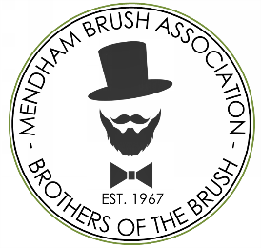
Tom Fichtner, Co-Chair
AJ Byrne, Co-Chair
Bruce Clifton
Rich Schofield
Aram Babaian
Peter Chauvin
Mendham Brush Association
Brothers of the Brush
P.O. Box 551
Mendon, Massachusetts 01756
E: mendonbrush@gmail.com

Please return this completed form to the Brothers of the Brush by March 29th, 2026
The Mendham Brush Association would like to thank you for your interest in purchasing a flag to honor those past and present who have served, or are serving, in our armed forces.
All flags are 30” x 60”, double sided, and made of high-quality durable vinyl printed with the American flag, a choice of either a photo of your honoree or an image of a circle of 13 stars surrounding a silhouette of a Minuteman to give a nod to our 250th anniversary, and your specific message. The purchase of a flag is good for (2) seasons from date of purchase, which spans from Memorial Day to Veterans Day each year, at the end of which the flag will be returned to the purchaser for their reuse and enjoyment.
If you want your flag to include a photo of your honoree you have two choices for submission in order to ensure a quality result:
- Email a high-quality portrait (larger than 1mb) to rich@richschofield.com – or –
- Allow us to take a high-quality scan of your original by request to the same e-mail address above

Purchaser  Your name |  |  |  |  | Flag Message  e.g. “In honor of” or “In Memory of”. Please keep short.
Street Address  123 anyplace street |  |  |  |  | Name of Honored  enter honoree’s name
City  anytown |  | State  MA | Zip  5 digit zip |  | Branch of Service:  choose branch
Phone Number  (xxx) xxx-xxxx |  |  |  |  | Conflict  choose conflict | Theater  choose theater
e-Mail Address  username@domain.com |  |  |  |  | Image Choice  choose an image
Please send your $250 check, payable Mendham Brush Association, along with this completed form, to: P.O. Box 551, Mendon, MA, 01756 Attn: Flag Committee

Purchaser Signature: |  |  |  |  |  | Date:

Thank you,

Mendham Brush Association – Flag Committee
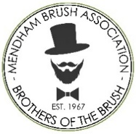
Mendham Brush Association
2026-2027 Flag Program

The Mendham Brush Association wishes to announce a new opportunity to honor a friend or loved one who has served, or is serving, in our armed forces by participating in our Flag Program. A flag purchase is for a 2-year period and will be hung each year prior to Memorial Day and removed in the fall after Veterans Day.
The appearance of these flags, in the center of Town and along the Memorial Day Parade route, adds to the solemnity of our Memorial Day Parade, as well as honors the participation of friends and family in the defense of our country.
To participate, we ask any Mendon resident interested to complete the Flag Purchase Form and mail the form along with a check for $250 to PO Box 551, Mendon, MA 01756.
You can download an electronically fillable copy from our website http://www.mendonbrothers.org/. Also, printed copies of the form can be obtained by visiting the Taft Library, Mendon Post Office, Mendon Senior Center, or the Mendon Town Hall.
The completed form along with payment must be received by March 29th, 2026, to allow for adequate processing time. There is a maximum of 52 flags which will be assigned first come, first served.
Questions may be sent to mendonbrush@gmail.com with “Flag Committee” anywhere in the subject.

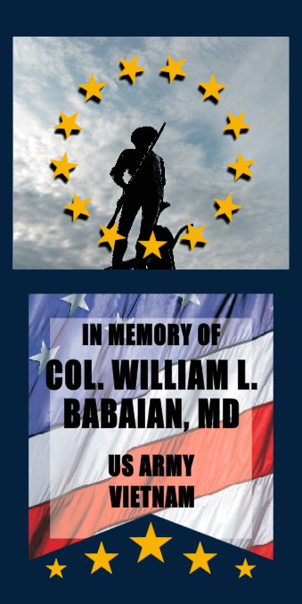

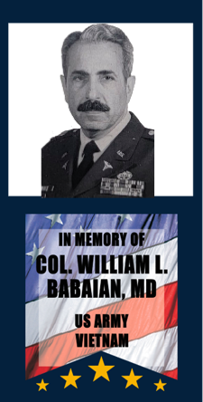
Design Options
Flags can be dedicated to a specific individual(s) or a more generic message.

Flags for a specific individual can include the service person’s name, branch of service, and any conflicts or theatres in which he/she served.

The design is still being finalized, but the final products will look substantially as these examples. The one on the left is the “honoree portrait” image option and the one to the right is the silhouette minuteman option.

