***ELDEN H. BARROWS MEMORIAL SCHOLARSHIP***

SPONSORED BY

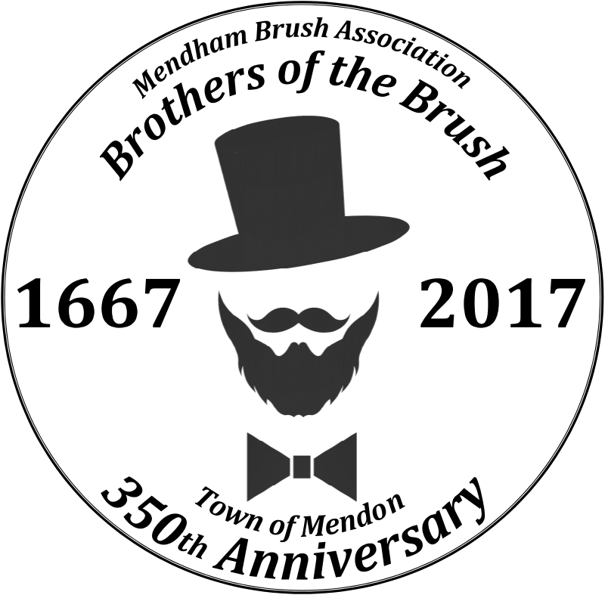

**Mendham Brush Association**

***Brothers of the Brush***  
P.O. Box 551

Mendon, Massachusetts 01756

Chad Labastie President

Bruce B. Bartlett Jr., Vice President

Tom Fichtner, Treasurer

Eric Weintraub, Secretary

Shawn Clifton, Sargent at Arms

**ELDEN H. BARROWS MEMORIAL SCHOLARSHIPS 2025**

The Mendham Brush Association (Brothers of the Brush) is pleased to announce the 2025 Elden H. Barrows Memorial Scholarship. Two $500 scholarships will be awarded to two graduating seniors who reside in Mendon from either Nipmuc Regional High School, Blackstone Valley Technical School, Norfolk County Agricultural, Mount St. Charles Academy or St. John’s High School with the intent to assist students with the cost of Higher Education, or tools and educational materials for entering the workforce.

The late Elden H. Barrows was one of the founders and prime movers of the original Jr. Baseball program in Mendon. He was also a coach for several years of the Pirates, a little league team. Mr. Barrows was also a founding member of the Brothers of the Brush and the first president and leader of the organization during Mendon’s 300th Anniversary Celebration.

As a club, The Mendham Brush Association is a local non-profit community organization dedicated to improving and promoting public spirit and cooperation in the community through fundraising and volunteerism efforts.  We provide support to local organizations, families, and individuals in Mendon as well as encourage general good fellowship among the community. The Mendham Brush Association has been supporting and volunteering in our community for over 50 years.

The awarding of scholarships is specific to graduating high school seniors who live in Mendon and who have provided service to their community and support to local organizations, families and or individuals in a manner consistent with the purpose of the Mendham Brush Association and have been accepted into either a technical, vocational, two or four-year higher-education accredited program, or secured a position in their chosen career path.

In addition to the evaluation being based on service and support within your community, academic achievement and extracurricular activities, application content and completeness are also factored into the decision process.

For those who meet the requirements above and have an interest in applying for this scholarship, please complete the attached application and submit it to your School Counselor’s Office no later than April 11th, 2025.

For all others, please mail your application (postmark by April 134h, 2025) to:

**Elden H. Barrows Memorial Scholarship**

C/O Mendham Brush Association

P.O. Box 551

Mendon, Massachusetts 01756

***ELDEN H. BARROWS Community Service* MEMORIAL SCHOLARSHIP**

SPONSORED BY

**Mendham Brush Association**

***Brothers of the Brush***

**APPLICATION**

***INSTRUCTIONS***

Please print or type clearly. This application will be used to evaluate the awarding of scholarships given to graduating high school seniors who have provided service to their community and support to local organizations, families and or individuals in a manner consistent with the purpose of the Mendham Brush Association and have been accepted into either a technical, vocational, two or four-year higher-education accredited program.

In addition to the evaluation being based on service and support within your community, academic achievement and extracurricular activities, application content and completeness are also factored into the decision process.

Be sure to provide specifics. Please attach references, additional information, and supporting documentation such as; a resume, a recommendation letter, school transcripts, etc. to support your application. The Mendham Brothers of the Brush – Elden H. Barrows Memorial Scholarship Committee will determine monetary awards based on the aforementioned categories reflected within the application submitted. Thank you.

***PERSONAL INFORMATION***

|  |  |  |  |  |  |  |  |
| --- | --- | --- | --- | --- | --- | --- | --- |
| Name: |  | | | | | Telephone: |  |
| Email Address: |  | | | | |  |  |
| Address: |  | | |  |  |  |  |
| City: |  | | | State: |  | Zip: |  |
| Parent /Guardian #1 Name: | |  |  | |  | Occupation: |  |
| Parent / Guardian #2 Name: | |  |  | |  | Occupation: |  |

***EDUCATION AND SCHOLARSHIP INFORMATION***

|  |
| --- |
| List all High School(s) attended; |
|  |
|  |
| List all higher-education schools or places of employment at which you have been accepted (in order of preference): |
|  |
|  |
| List any other scholarships and amounts which you have applied for: |
|  |
|  |
|  |

|  |  |  |  |  |  |  |  |  |  |  |  |  |  |  |  |  |  |  |  |  |  |  |  |  |  |  |  |  |  |
| --- | --- | --- | --- | --- | --- | --- | --- | --- | --- | --- | --- | --- | --- | --- | --- | --- | --- | --- | --- | --- | --- | --- | --- | --- | --- | --- | --- | --- | --- |
| ***SCHOOL AND COMMUNITY INVOLVEMENT***   |  | | --- | | List all school activities in which you have participated and the duration or years of participation: | |  | |  | |  | |  | | List all community and outside activities in which you have participated and the duration or years of  participation: | |  | |  | |  | |  | | List all honors and awards received during high-school: | |  | |  | |  | |  | | Please describe in 1-2 paragraphs what your participation in the community means or has meant to you.  Include a reference to Elden H. Barrows (citizen of Mendon) and his service to the community. *Reference the attached*  *biography and citations for information on Eldon H. Barrows* | |  | |  | |  | |  | |  | |  | |  | |  | |  | |  | |  | |  | |  | |

For seniors attending either Nipmuc Regional High School or Blackstone Valley Technical School, please submit your completed application to the School Councilor’s Office no later than April 11th, 2025.

For all others, please mail your application (postmark by April 1413h, 2025) to:

**Elden H. Barrows Memorial Scholarship**

C/O Mendham Brush Association

P.O. Box 551

Mendon, Massachusetts 01756

|  |  |  |  |
| --- | --- | --- | --- |
| Signature of Applicant: |  | Date: |  |

**NOTE: All applications submitted to the Mendham Brush Association are the sole property of the Mendham Brush Association and are kept strictly confidential.**

***HIGH SCHOOL COUNSELOR INFORMATION***

|  |
| --- |
| Please list any attributes this candidate has that would assist the scholarship committee in its evaluation-selection  process: |

|  |  |  |  |
| --- | --- | --- | --- |
| Signature of School Counselor: |  | Date: |  |

**Elden H. Barrows**

***An Essay by Jared Heather***

***(Previous scholarship recipient)***

Born on November 25th, 1926, Elden H. Barrows was raised in the small town of Mendon, Massachusetts. As a devoted member of the Mendon community, Barrows sought to make the town a better place for the people living there and wanted to celebrate the town’s establishment. In 1967, the town of Mendon was officially 300 years old and with the leadership of Barrows, this historic period was turned into a celebration that would leave a lasting impact on the community of this municipality. To mark this notable year, Barrows created a group called the “Mendham Brothers of the Brush” which planned and organized the events as well as generated community interest and support for this anniversary. As prime mover and President of this group, Barrows initiated a Razor Burial to symbolize the future growth of Mendon, kicking off the celebration. Additionally, Barrows put together other festivities such as costume dances, tree plantings, historical pageants and church services. He also included local clubs in carrying out these festivities, hoping to boost membership in their programs. Concluding in June of that year, Barrows popularity grew among the Mendon population, as he had honored the history of Mendon while bringing the community closer together. His selfless personality and love for his town was admired by all community members, making him one of the faces of the town of Mendon.

While the six month commemoration of Mendon’s 300th anniversary was his most notable act, Barrows also had other influences around the town. He was the manager of a little league team called the Pirates, coaching kids from a young age. He was also and ‘Akela” Cub Scout Leader, developing younger students’ skill sets inside and outside of school. He was a member of the Bicentennial Commission for the Town of Mendon as well as being a member on the Planning Board. Outside of the community, Barrows served in World War 2 as a part of the Navy, taking on the ultimate act of bravery and selflessness. He always strived to do good in the world and change it for the better, no matter how big or small of an impact he had. On May 22nd, 1980, Mendon lost a community leader and a kind-hearted person in Barrows. His legacy lives on through the Mendham Brothers of the Brush organization that still stands today, “promoting public spirit and cooperation through volunteerism and community efforts”. There is now a road (Barrow’s Road) in Mendon, commemorating what he meant to the community. Barrow’s commitment to the town of Mendon has created a lasting devotion in the town to community service and volunteerism, creating the tight-knit and public-spirited community that I live in today.

**References**

<http://www.mendhambrothersofthebrush.org/shaving_permit>

<https://www.hope1842.com/hope1842/mendon300th.html>

<https://www.findagrave.com/memorial/39917805/elden-hubert-barrows>

<https://archive.org/details/annualreportsoft1980mend/page/2/mode/2up>